CSCI 4940 – Capstone Project

Group #5

Members: Morgan Channel – Raymond Chui – Christopher Clark – Cedric Crawford

Professor: Dr. Ge

February Progress Report

# Problem Formulation

For the month of February, we wanted to make an early version of the boss fight for our dungeon that could be demoed at the midterm. This would require detailed design planning for the boss and its move-set, the dungeon room, the player mechanics, and anything else that would be appropriate to implement for this boss fight. This would also include testing and implementing other areas of the game such as basic enemies, as this would allow us to better understand how the boss fight should behave as well as allow for easy testing of other systems such as player health, movement, and attacks.

# Analysis of the Problem

First, we discussed the layout of the dungeon room. We settled on a room with platforms around the center that the player could swing across to access different platforms, using his snake familiar obtained earlier in the dungeon as a grappling hook. As for the boss, we decided on a vine-creature that would periodically open and close its eye. The player must use the snake to fling projectiles (tree branches, pinecones, etc.) into the eye at precisely the right time to damage the boss. The boss would attack with vines that seep underground and attack the player from below. In order for all of this to work smoothly, many other features would also have to be implemented such as player/boss health, damage system, snake mechanics, etc. Everything would have to be hand-drawn before any work could be done with the code. We decided to focus our efforts into writing what we need for the early prototyping in GDScript, the Godot scripting language, until later revising in C++ once we have a design plan for the full architecture of the game’s code.

# Implementation

We have drawn all of the designs for the boss fight, including the layout of the room, the boss itself along with its animations, and the player. We have implemented an early version of a health/damage system for the player and have done some testing using other basic enemies.

# Member Contributions

### Christopher Clark

I created a few sprites for enemies for our game. One enemy is a Katydid, a flying insect that will fly across the screen. If the Katydid touches the player sprite, it will damage the player. I also created some prototype code to demonstrate this. In addition, I also created a sword sprite for the player to hold and use as a weapon against enemies. Again, I created prototype code to demonstrate the swinging motion of the sword and also damage towards the Katydid Sprite. I also created a sprite for our dungeon boss, which is a plant-like monster with vines extending out from its body and an opening and closing eye in the center. I created prototype code to animate this monster, but I have yet to implement any other code for it. Aside from enemies, I also created a helper Snake, which is a creature that functions mostly as a tool. The snake’s sprite is generated, but prototype code has not been implemented yet. Finally, I worked out some problems we were having with using C++ libraries in Godot, and now we will be able to code aspects of our game in C++.

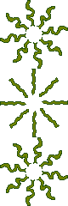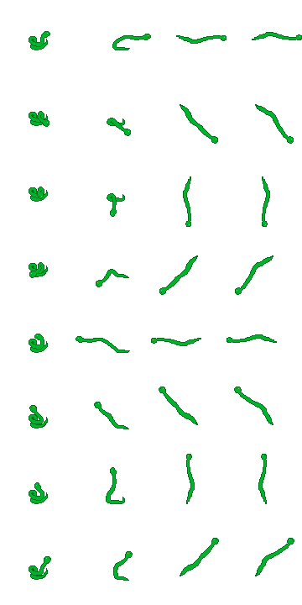

# Raymond Chui

# Morgan Channell

Created basic enemies with complete 4-directional walking animations including a wolf, a fox, and a dryad. Was a part of prototyping the code for basic AI movement and attack systems for basic enemies, working with collision shapes, aggro system (which will ultimately be replaced by a generic targeting system when we fully flesh out the C++ code), and health/damage between both enemies and the player. Select drawn designs can be seen below.

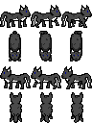 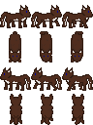

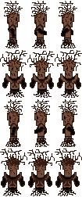

# Cedric Crawford